Ch 1 Lesson 4 What Influences Our Observation BMW Commercial

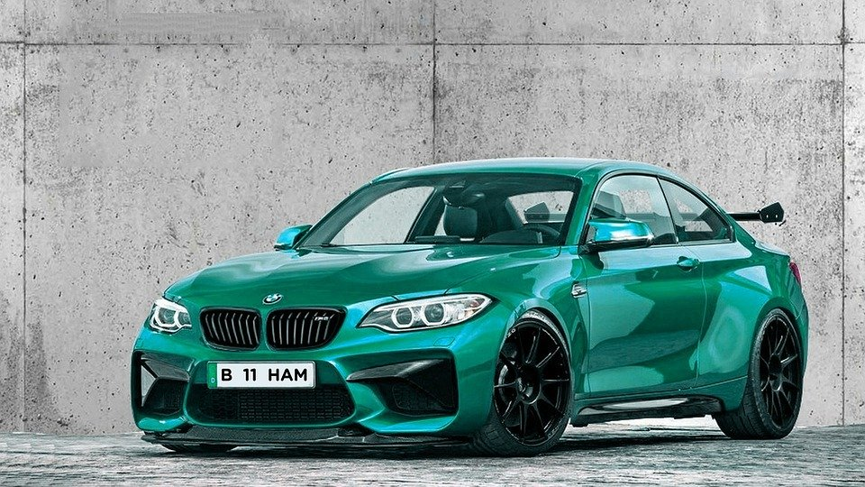

Please watch the BMW Commercial once. Do not look at questions while viewing.

After viewing it once:
- What was the color of the car?
- Was the main male character wearing a necktie?
- What was the color of the hair of the toy shop lady?
- What kinds of toys did you see in the shop?
- Did you see the license plate number on the car? If so, what was it?
- What was the main female character wearing?
- Did she have any ring on her finger?
- What was her hair color?
- What kind of footwear was she wearing?

Discussion point: Filter what we want to see only.
- What was the name of the street the jewelry shop was on?
- What season was this?
- Where was this shot? In America? Germany? Why do you think this?

Discussion point: Filling in gaps with our personal knowledge and experience.

Please watch the BMW Commercial again.

After viewing the second time without sound:
- What color was the tie on the jeweler?
- Handkerchief color?
- Did the policemen have ties?
- What color were they?
- Did they have gloves on?
- What was the license plate number?
- Did the main character have a ring on his finger?
- How old do you think he is?
- How tall was he?
- How tall was the main female character?
- Was she taller or shorter than the male character?

