Instant Challenge: Paper Bridge

In this activity students will work as a team to design a paper bridge and document their process in their engineering notebook.

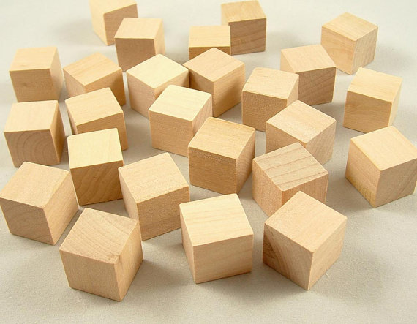

Equipment
- Engineering notebook
- Pencil
- ¾-in. wooden blocks (2)
- 1 sheet of 8 ½ x 11 in. cardstock
- Assorted construction tools such as scissors

Procedure
- Follow the direction of the teacher while completing this activity.
- Use the design process learned earlier in this lesson. Document each step in your engineering notebook.
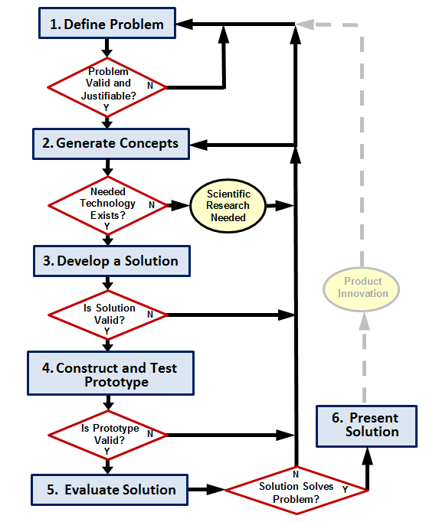
- Design and build a product that maximizes the distance between two blocks which are connected by a continuous route of paper. The product must meet the constraints below.
  - The paper must form a continuous chain of connectivity from one block to another without touching the tabletop.
  - Paper-to-paper linkage will be considered continuous.
  - The two wooden blocks are ¾-in. wooden blocks.
  - Both blocks are at table height.
  - Cardstock can be modified.
  - Additional material can be used during construction, but not on the final product.
- The winning design meets the constraints above with the blocks farthest apart.

